Documentation for Assignment 3
Group members:
Manojna Reddy Kamaram: 2024334
Palak: 2024399
Shanthini Muralidhar: 2024520

A3: Creating a Mini Packet Analyzer
Github Link: https://github.com/shanthini11/CN_A3
Overall preview
Our mini packet analyzer’s main goal here is to replicate the same doings of the Wireshark application

Functionalities to replicate includes:
- Captures network frames sent or received by the host, and numbers and timestamps each parsed packet.
- Shows the packet size, source/destination addresses, ports and protocol in a summary table.
- Decodes the IPv4, TCP and UDP headers manually from the raw bytes. Scapy is used only to capture the raw frames; it is not used to decode any header.
- Filters packets by protocol (TCP/UDP), source/destination IP and source/destination port.
- Displays a selected packet's IP header, TCP/UDP header, and payload in hexadecimal and text form
How do all the files work together?
- The main python file first asks for the network interface, max packet counts and capture duration
- Next, the capture file will use the sniff() function from Scapy to help capture frames and record bytes(packets) with a timestamp
- The parser file converts each raw frame into a packet dictionary. It only recognizes Ethernet frames carrying IPv4 (with or without a VLAN tag); any other frame, such as ARP or IPv6, is skipped.
- The menu helps the user choose whatever option they like to parse after running the main file and lets the user show all the parsed packets, filter packets, inspects the packet by a specific number or exit the program
How do we set it up in your personal systems?
MacOS/Linux System
Run these commands in the project folder:
python3 -m venv .venv
source .venv/bin/activate
python -m pip install -r requirements.txt
python test_parser.py
python test_filters.py
python test_display.py
python main.py

If packet capture fails because of permissions on macOS, try:
sudo .venv/bin/python main.py

Choose the interface connected to your network. On many Macs, Wi-Fi is en0, but use the list printed by the program. Start ordinary network activity during capture to help collect packets
Windows System
First we Install Npcap (Scapy needs it to capture packets on Windows). Keep the default installer options. Then, Run these commands in PowerShell in the project folder:
py -m venv .venv
.\.venv\Scripts\Activate.ps1
py -m pip install -r requirements.txt
py test_parser.py
py test_filters.py
py test_display.py
py main.py

If PowerShell blocks Activate.ps1, use Command Prompt and run .venv\Scripts\activate.bat instead.
The program lists interfaces by number with their friendly names (for example Wi-Fi) and marks the default one; press Enter to use it. If capture fails with a permission error, open the terminal with Run as administrator
Running the Program now
From the activated environment we should now run:
python main.py (for windows you can write it as py main.py)
After this:
- Select the interface you want to capture on (a numbered interface, or its name, or just press enter to select the default interface)
- Set the capture limits by entering the maximum packet or frame count( or you can put the default value 50) as well as the duration in seconds(you can put the default value as 15). The capture will stop as soon as any limit is reached
- Generate ordinary traffic where you can open a website or run a normal DNS lookup in another terminal during the capture
- Then you can use the menu through options 1-4 as per the user’s wish
Menu and it’s options meaning here
- Show all parsed IPv4 packets
- Filter by protocol, source/destination IP and/or source/destination port. Leave a field blank to skip it. Invalid values (for example a port above 65535 or a malformed IP) are reported and no filter is applied
- Inspect the full details for a packet number
- Exit

How a packet is decoded from bytes
All multi-byte fields are big-endian (network byte order) and are read with int.from_bytes(data, "big"). Offsets are counted from the start of each header.
Ethernet header (14 bytes)
Bytes 12–13 are the EtherType. 0x0800 means IPv4; anything else is skipped. For an ordinary frame the IPv4 header starts at byte 14.
802.1Q VLAN tag (optional, 4 bytes)
If the EtherType is 0x8100, a VLAN tag has been inserted: bytes 14–15 hold the tag and bytes 16–17 hold the real EtherType, so the IPv4 header starts at byte 18.
IPv4 header (20–60 bytes)
Bytes | Field | How it is extracted
0 | Version, header length | version = byte >> 4; header_length = (byte & 0x0F) * 4 (the IHL counts 4-byte words)
2–3 | Total length | IPv4 header + data, excluding Ethernet
6–7 | Flags, fragment offset | fragment_offset = value & 0x1FFF; More Fragments flag = value & 0x2000
8 | TTL | One byte
9 | Protocol | 6 = TCP, 17 = UDP, 1 = ICMP — this is how TCP and UDP are identified automatically
10–11 | Header checksum | Shown in hexadecimal
12–15 / 16–19 | Source / destination IP | 4 bytes each, converted to dotted form with ipaddress.IPv4Address
The TCP/UDP header starts right after the IPv4 header, at ip_start + header_length. The IPv4 data ends at ip_start + total_length, so Ethernet padding is never counted as payload.
TCP header (20–60 bytes)
Bytes | Field | How it is extracted
0–1 / 2–3 | Source / destination port | 16-bit integers
4–7 / 8–11 | Sequence / acknowledgment number | 32-bit integers
12 | Header length (data offset) | (byte >> 4) * 4; values below 20 are invalid
13 | Flags | One bit each: FIN 0x01, SYN 0x02, RST 0x04, PSH 0x08, ACK 0x10, URG 0x20, ECE 0x40, CWR 0x80 (e.g. 0x18 = PSH + ACK)
14–15 | Window size | 16-bit integer
16–17 | Checksum | Shown in hexadecimal
TCP payload length = IP total length − IP header length − TCP header length.
UDP header (8 bytes)
Source port at bytes 0–1, destination port at 2–3, length at 4–5 and checksum at 6–7. The UDP length includes the 8-byte header, so payload length = UDP length − 8. A UDP length below 8, or larger than the IP data (except in the first fragment of a fragmented packet), is rejected.
Payload
Shown 16 bytes per line in hexadecimal, with the same bytes as text alongside. Printable ASCII bytes (0x20–0x7E) appear as characters (e.g. 0x48 = H); all other bytes appear as ".", because many payloads are binary or encrypted. A packet with no application data shows a payload length of 0 and "Empty payload."
Testing the system
Here we created and recorded various test cases to check how the system works. Tests were run on two machines: macOS (interface en0, IP 192.168.40.230) and Windows 11 (interface Wi-Fi, IP 192.168.40.117). Each screenshot is from one of these, and packet numbers differ between capture runs.

- Offline tests: where we check if all three suites passed the virtual environment or not
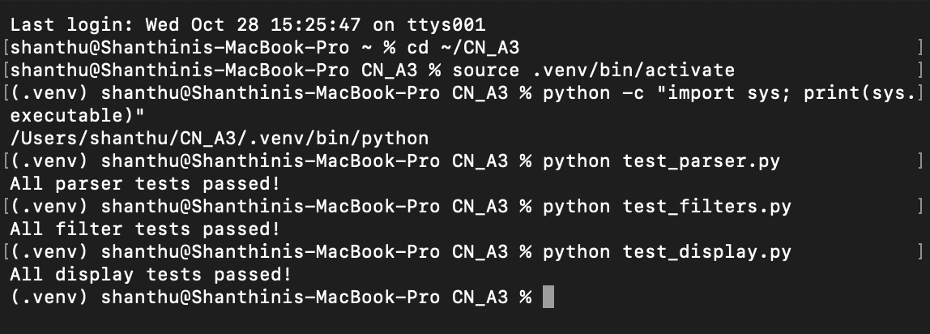
Result: All three offline test suites passed inside the virtual environment. These tests build packet bytes in code, so they need no network access or administrator rights.
- Checking Startup and Interface error tests
- Checking the network interface list and entering an out-of-range interface number
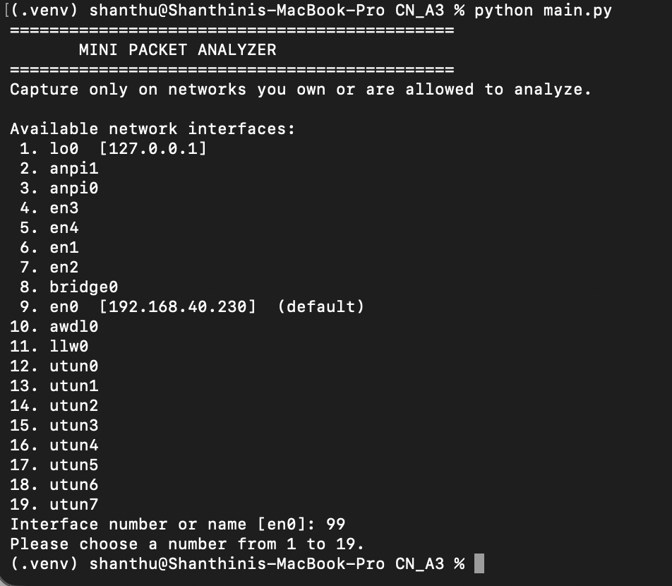
Result: The program listed 19 interfaces by number, showed the IP address next to en0 and marked it as the default. Entering 99 was rejected with "Please choose a number from 1 to 19."

- Testing a nonexistent interface name
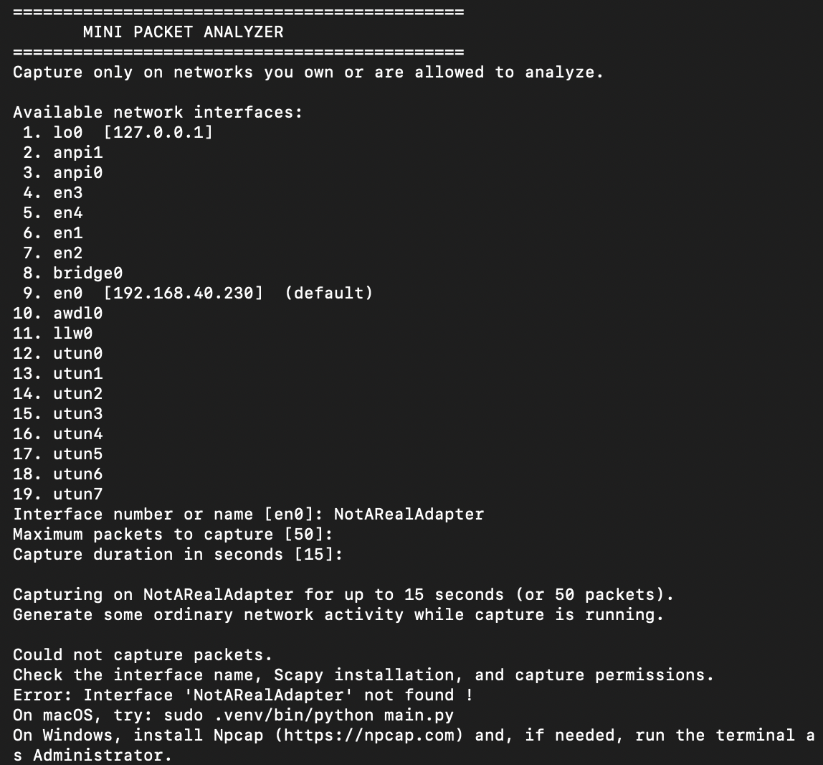
Result: A nonexistent interface name was accepted at the prompt, but capture failed safely with "Could not capture packets", the reason ("Interface 'NotARealAdapter' not found") and setup hints for macOS and Windows, instead of crashing.
(c) Testing a nonnumeric packet count
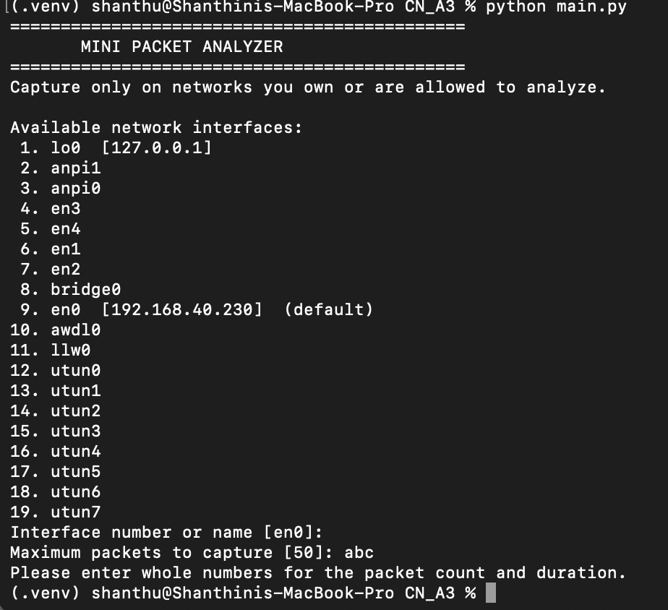
Result: A non-numeric packet count was rejected with "Please enter whole numbers for the packet count and duration."
(d) Testing a packet count of 0
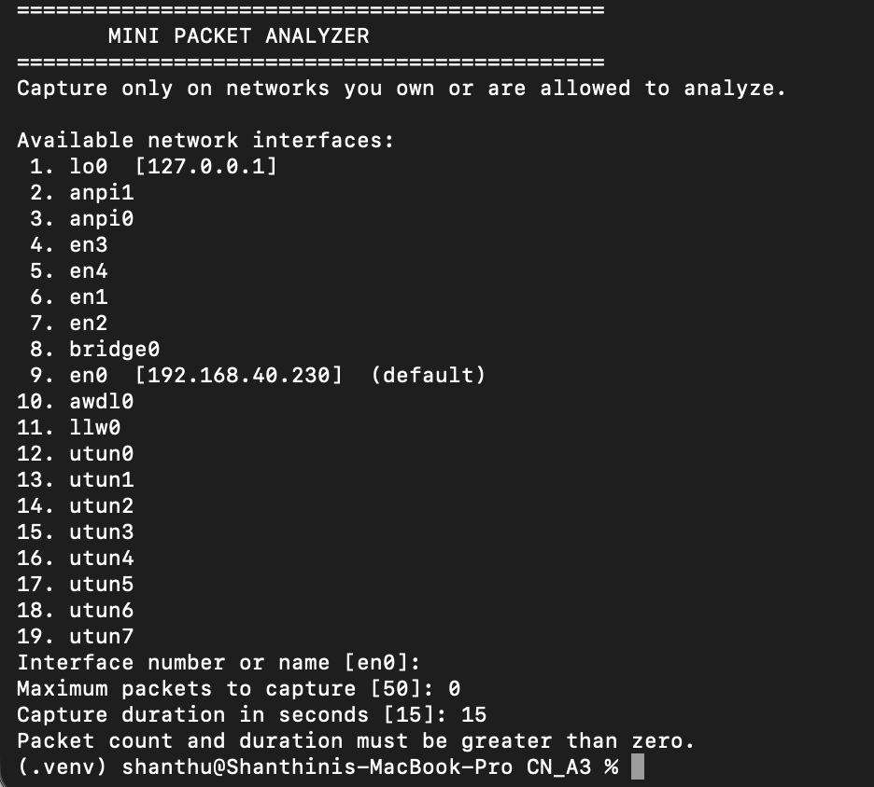
Result: A packet count of 0 was rejected with "Packet count and duration must be greater than zero."
(e) Testing a negative capture duration
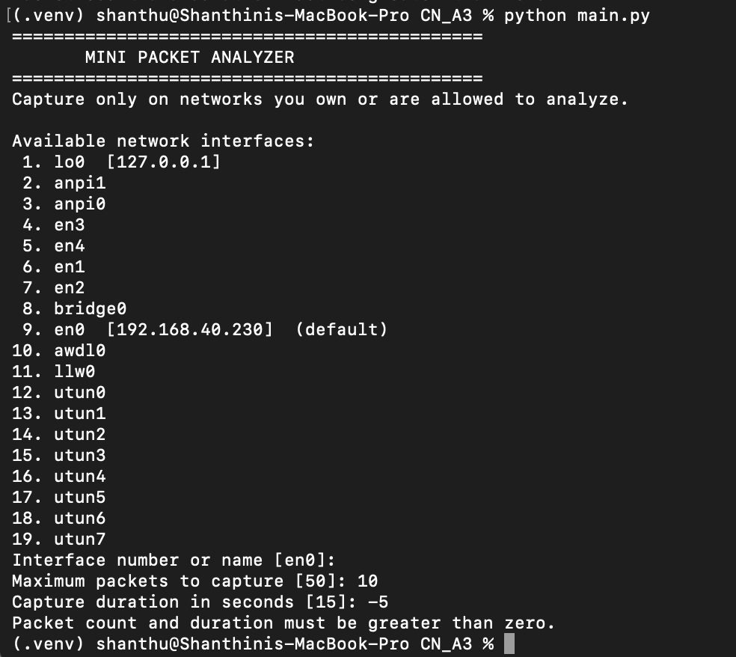
Result: A negative duration (-5) was rejected with the same message.
(f) Testing a valid live capture
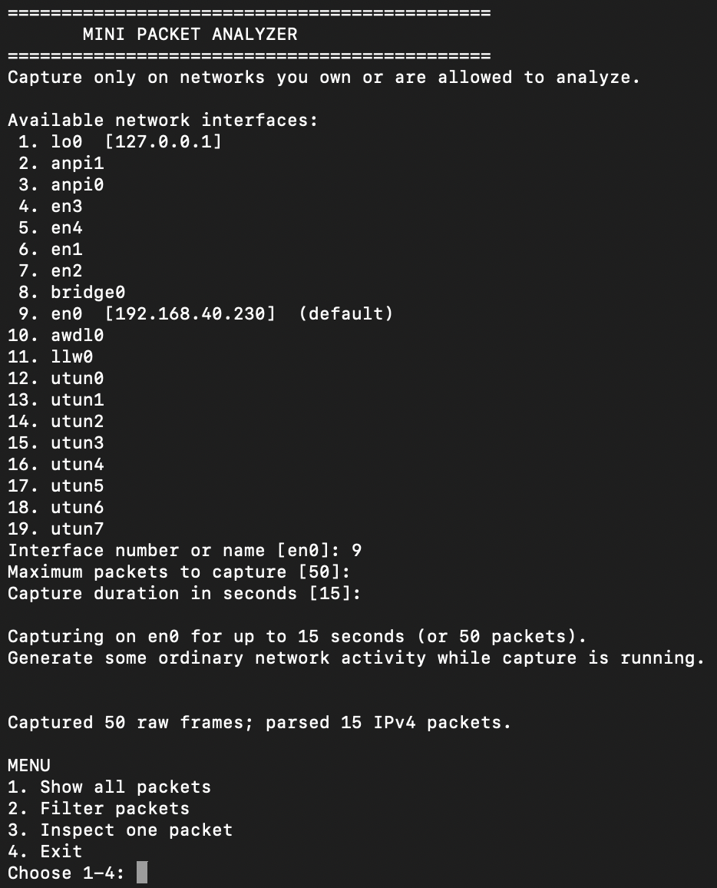
Result: Selecting interface 9 (en0) with the default limits captured 50 raw frames, of which 15 were IPv4 packets. The other frames (for example ARP and IPv6) are not IPv4, so the parser skips them, as designed.
3. Main Capturing Sessions
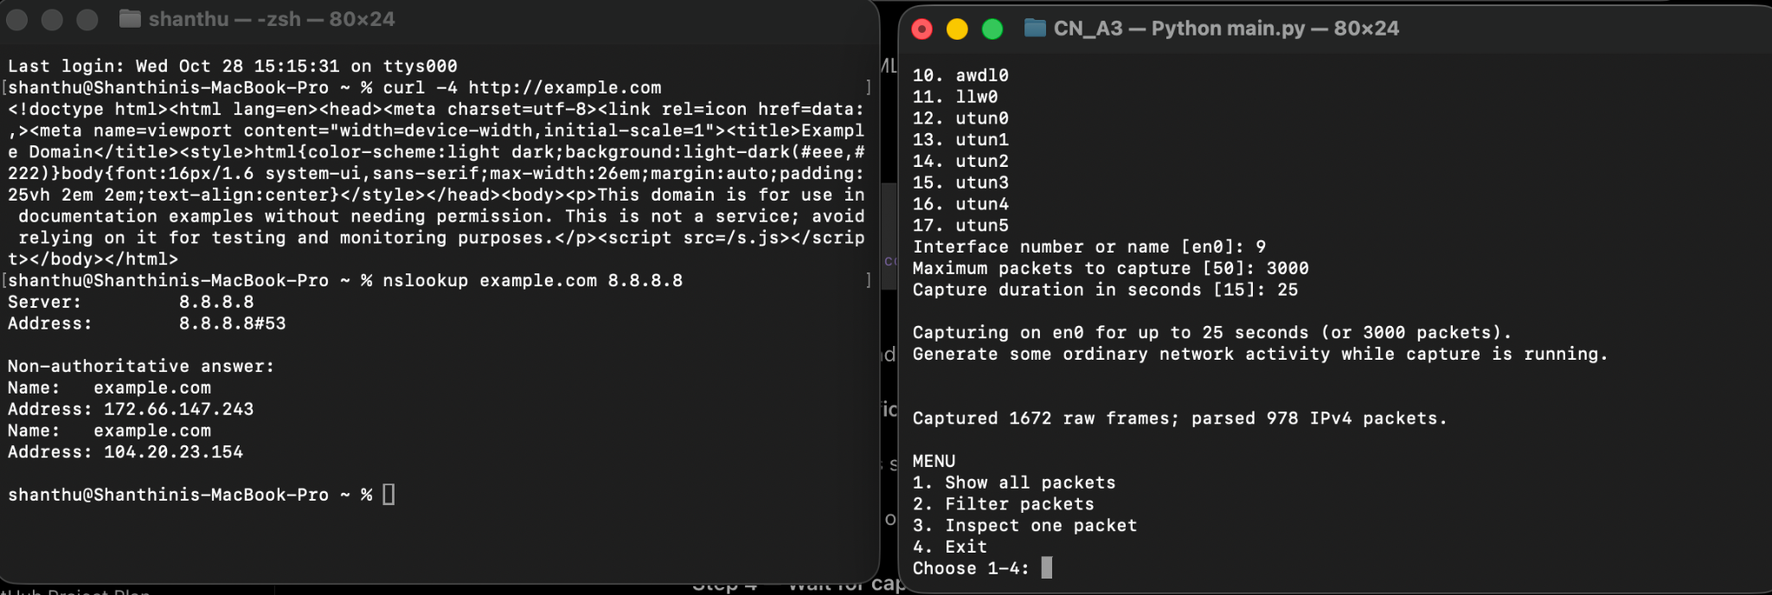
Here we ran the packet analyzer on my Mac’s Wi-Fi interface (en0) for 25 seconds while generating normal network traffic. Then we tested a HTTP request using curl and performed a DNS lookup using nslookup, which successfully returned IP addresses for example.com. The program captured 1,672 raw frames and parsed 978 IPv4 packets, after which the menu appeared as expected.
4. Summary capturing
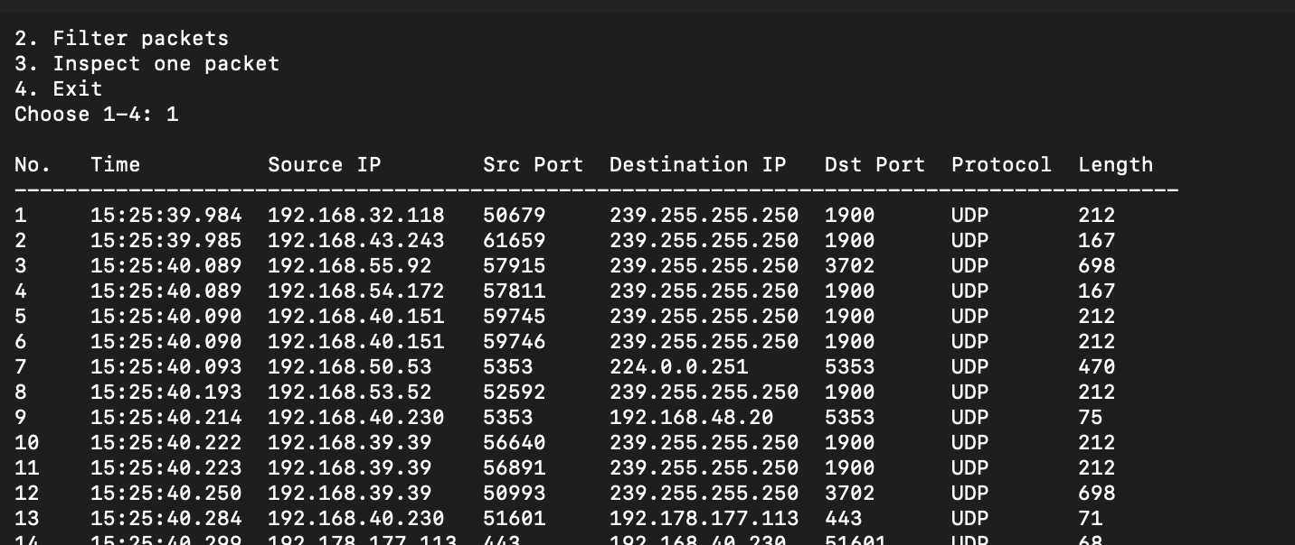
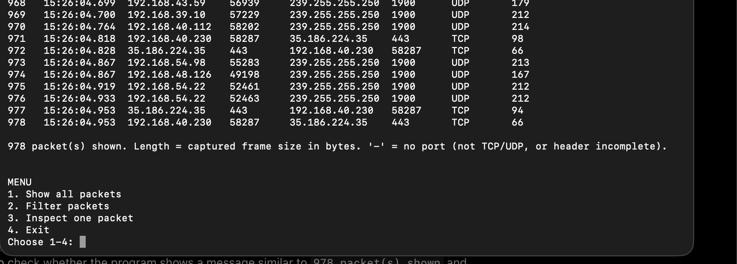
Selecting option 1 to display the captured packets and checked the summary table. It showed all the required columns, with packet numbers increasing sequentially and timestamps including milliseconds. The bottom of the table confirmed that 978 packets were displayed and explained the meaning of packet length and unavailable ports. Overall, all summary checks passed successfully. The first rows show local discovery traffic (SSDP to 239.255.255.250:1900 and mDNS on port 5353) and the last rows show TCP traffic on port 443.

5. Checking all the filters
- Filtering by TCP
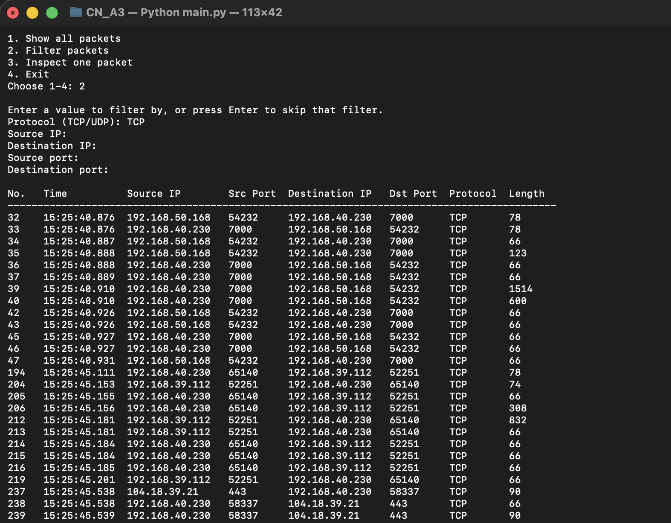
Result: Only TCP rows were returned (for example ports 7000/54232 on the local network and HTTPS on port 443).
- Testing the lowercase UDP when typed in the system
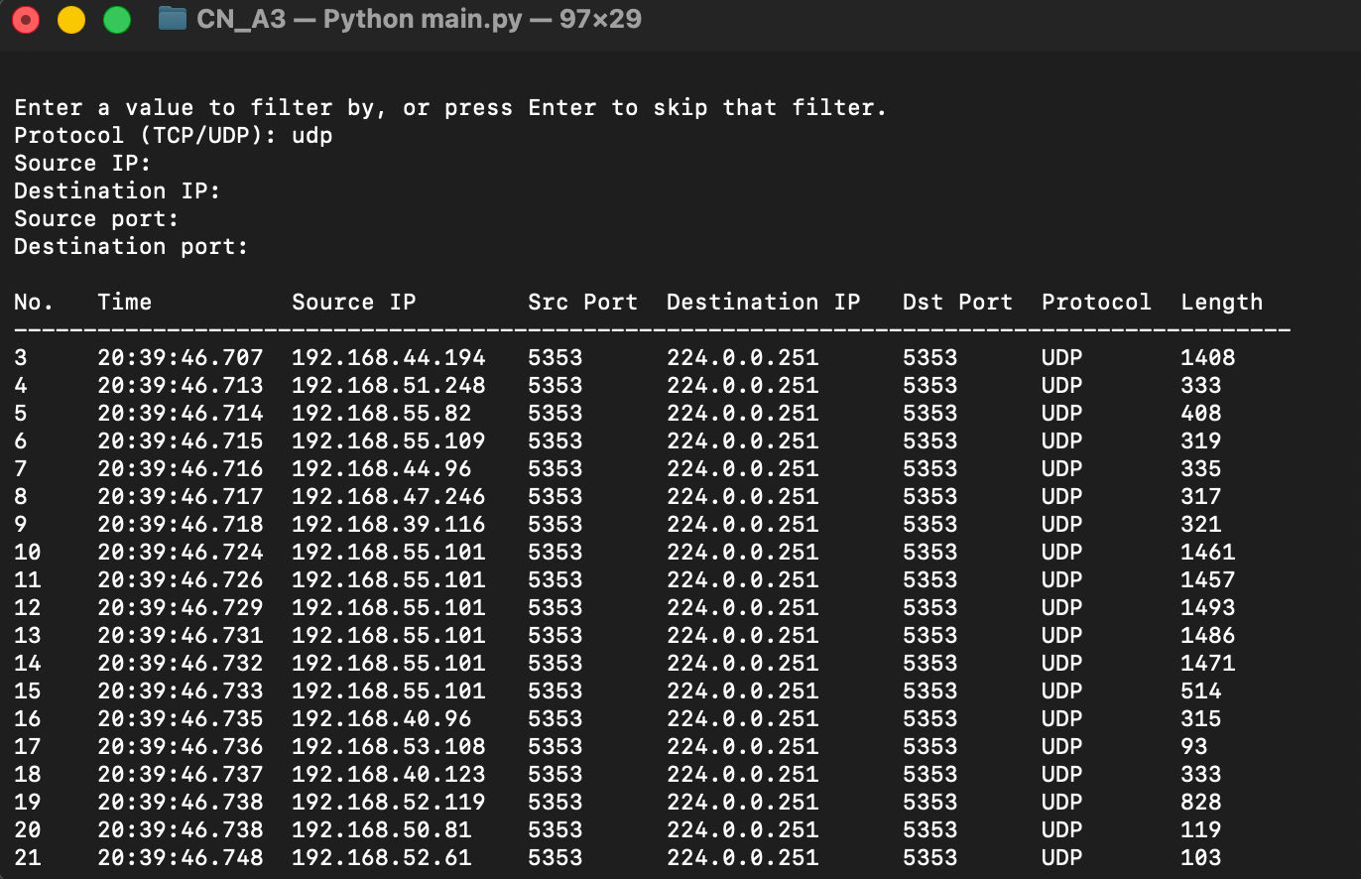
Result: Typing "udp" in lowercase returned only UDP rows, so protocol input is not case sensitive.
(c) Filtering with Mac’s Source IP address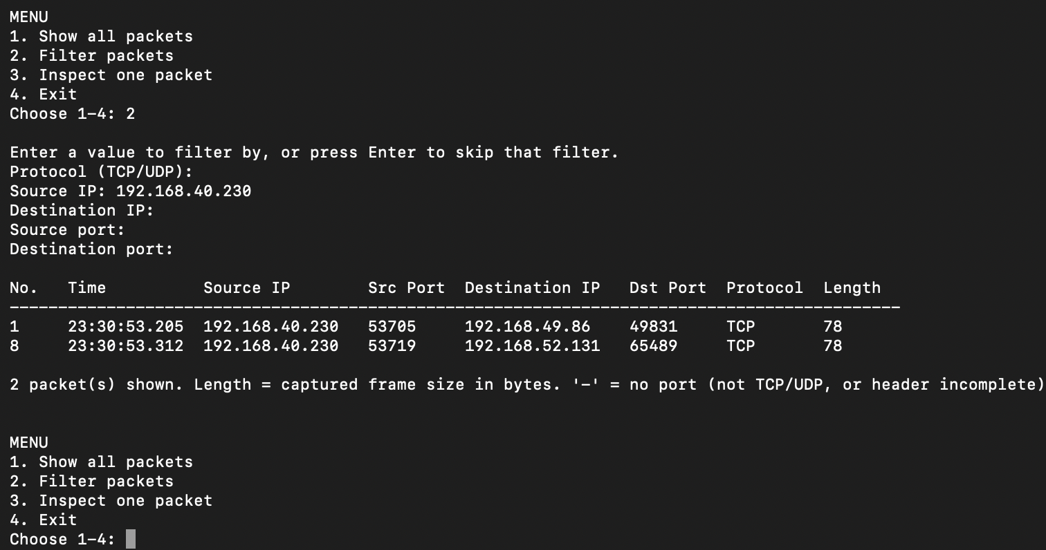
Result: Only packets sent by the Mac (source 192.168.40.230) were returned.
(d) Filtering by destination IP address
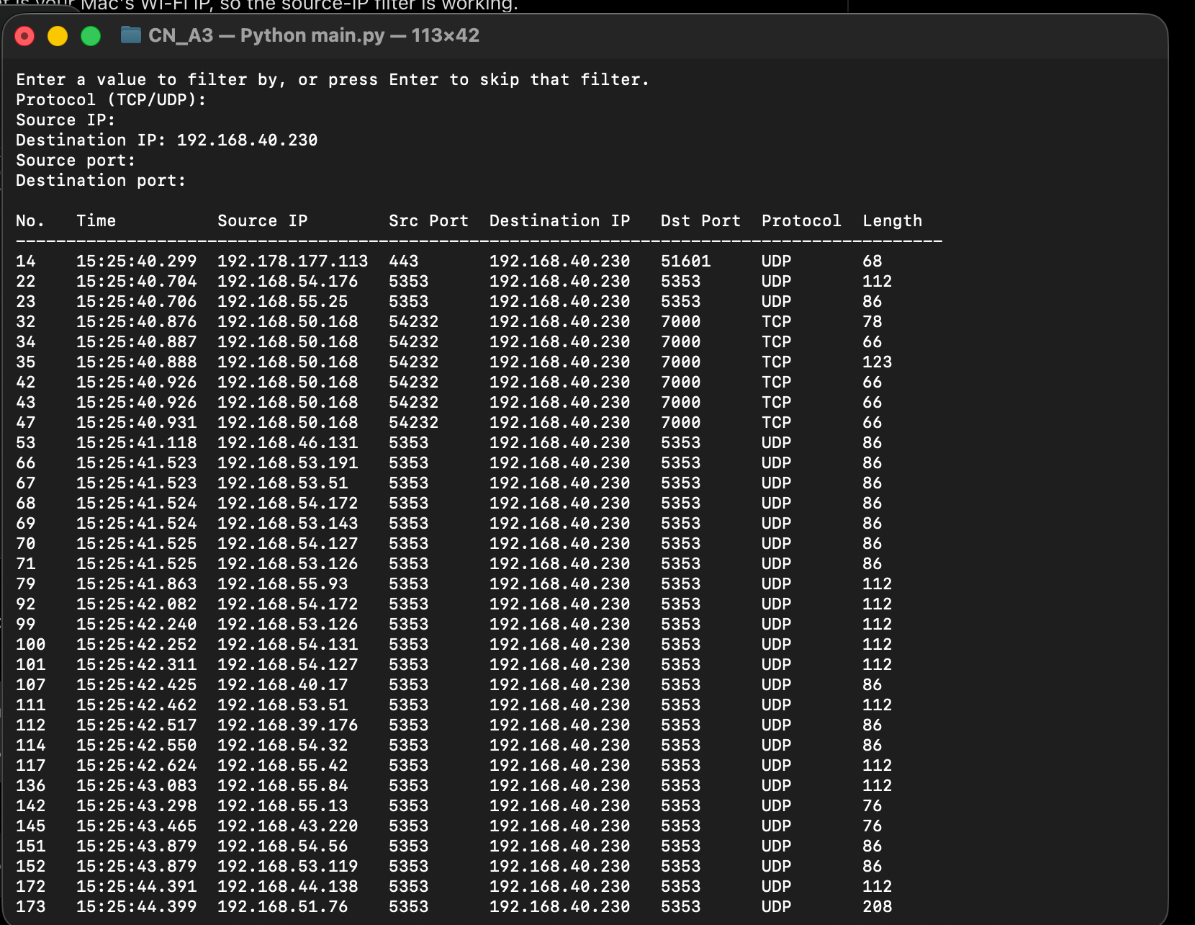
Result: Only packets received by the Mac (destination 192.168.40.230) were returned, including UDP replies and incoming TCP segments.
(e) Filtering by destination IP address(8.8.8.8)
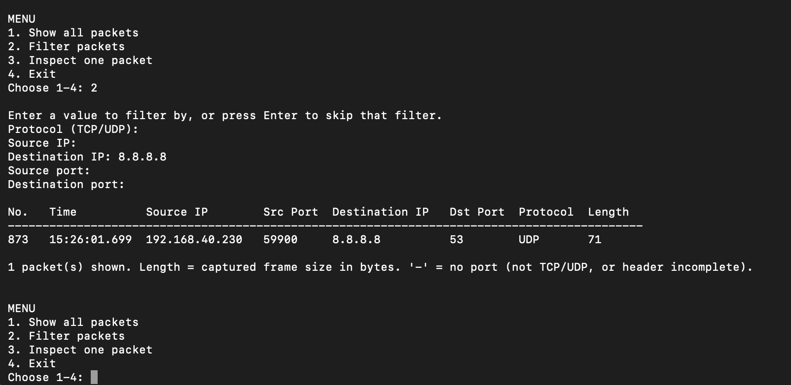
Result: Only the DNS query sent to Google's DNS server (UDP, destination port 53) was returned.
(f) Filtering the HTTP requests on the TCP port 80
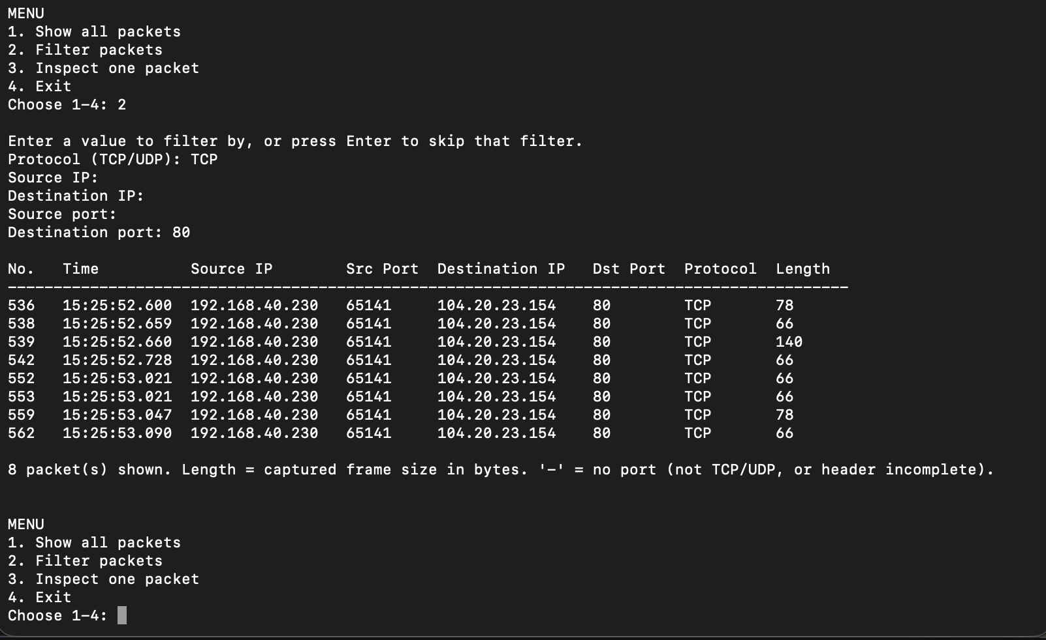
Result: The client's packets of the HTTP connection to example.com (104.20.23.154) were returned: the connection handshake, the GET request (140 bytes) and the acknowledgements.
(g) Filtering the TCP responses from the source port 80
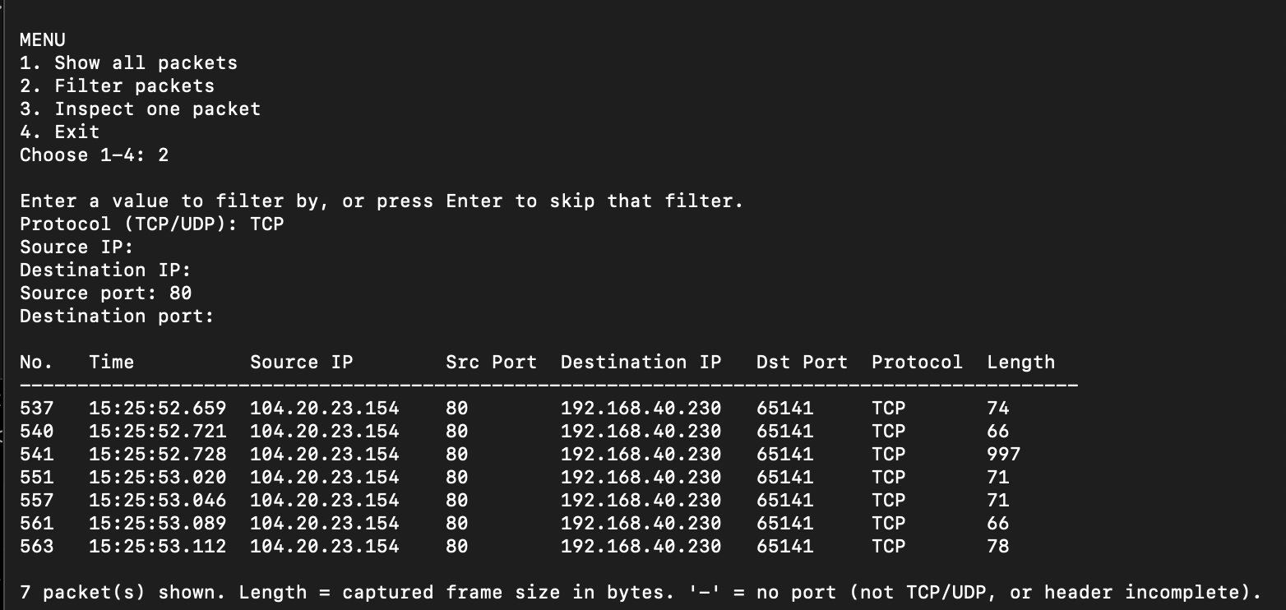
Result: The server's replies in the same connection were returned, including the 997-byte HTTP response.
(h) Filtering the HTTPS traffic (where the TCP destination port here is 443)
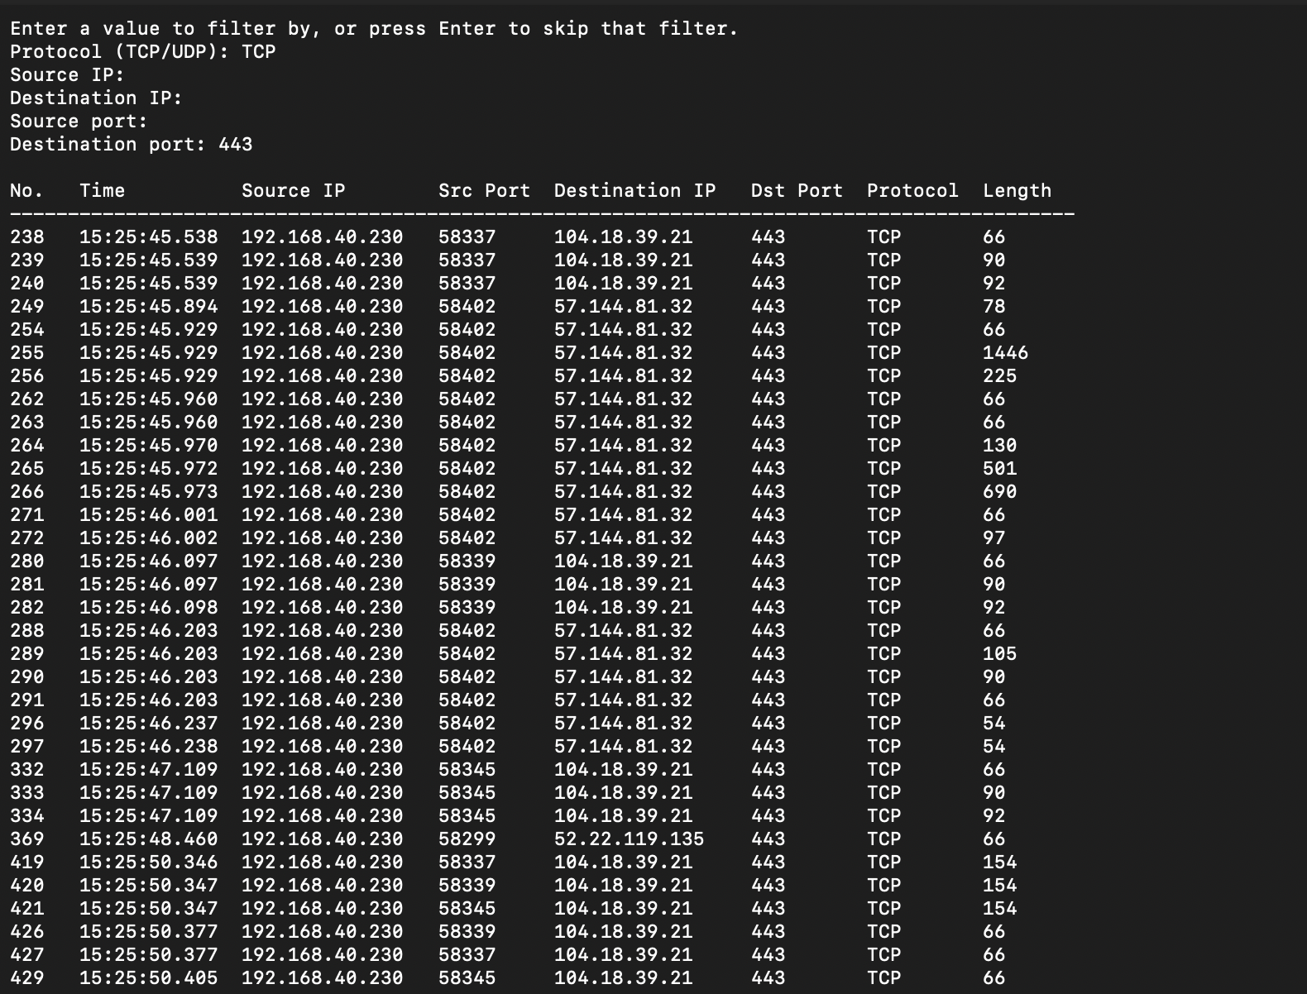
Result: HTTPS traffic from the Mac to several web servers was returned.
(i) Checking the UDP port for 443 using QUIC
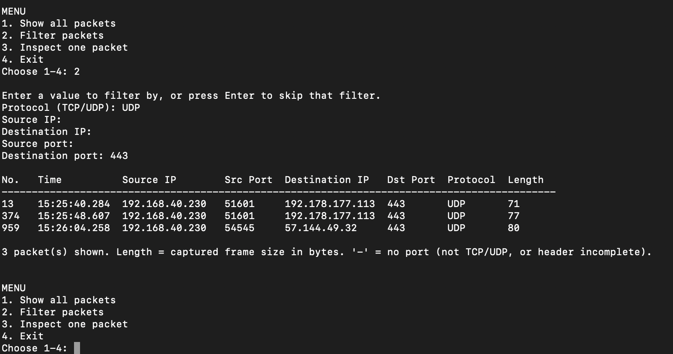
Result: Three QUIC packets (HTTP/3 over UDP) were found.
(j) Testing the destination port 0080
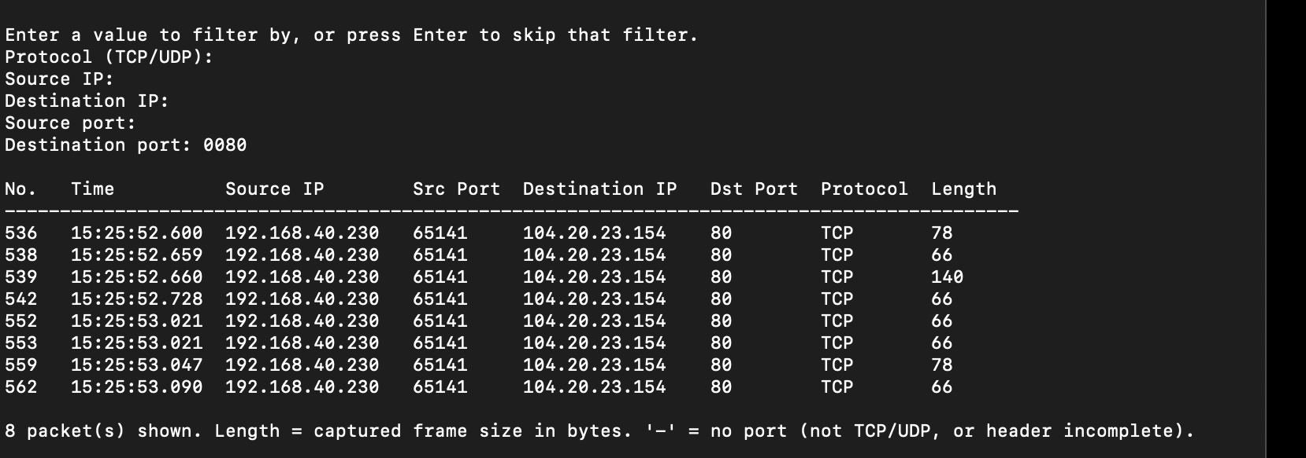
Result: The same 8 packets as (f) were returned, because ports are compared as numbers, so leading zeros do not matter.
(k) Combined UDP with destination IP and port
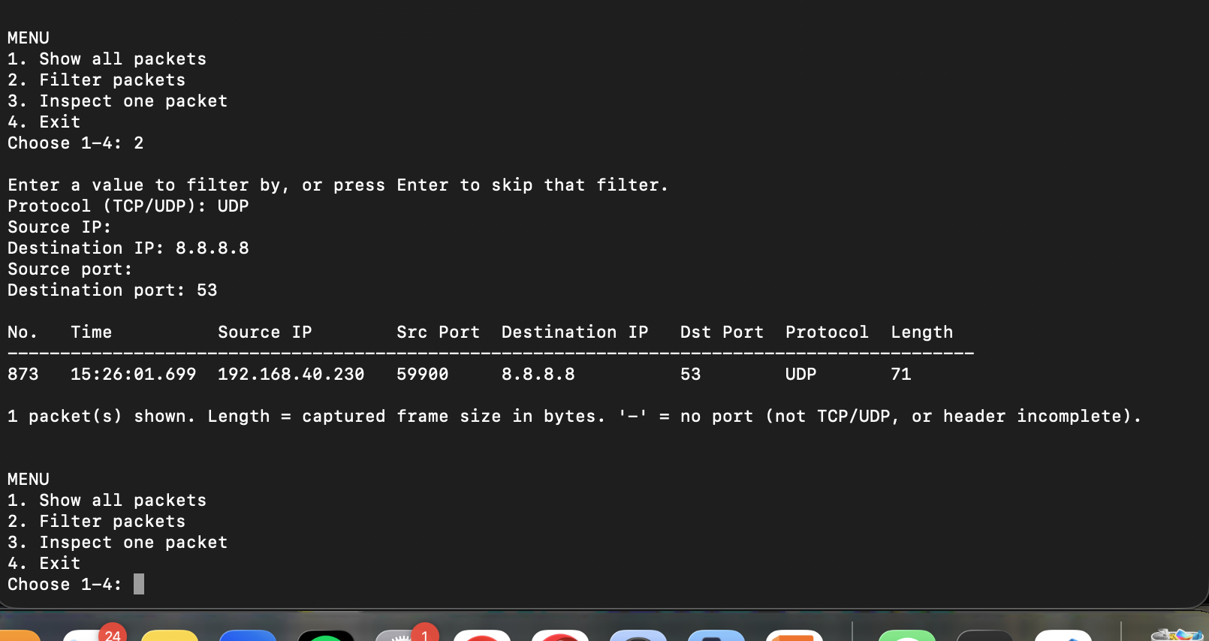
Result: All three conditions must match, so only the DNS query was returned.
(l) Combined TCP with source IP and destination port 80
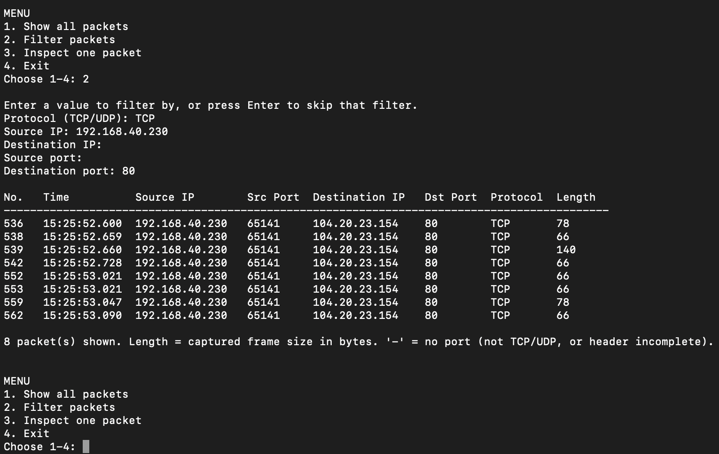
Result: The same 8 packets as (f) were returned, confirming that combined filters narrow the results correctly.
(m) Testing the destination port filter with no matching packets (port 12345)
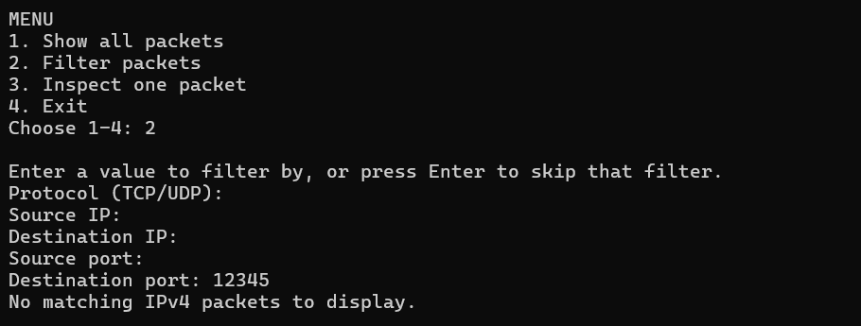
Result: No packet used this port, so "No matching IPv4 packets to display." was shown.
(n) Testing the combined TCP protocol and destination port 53 filter
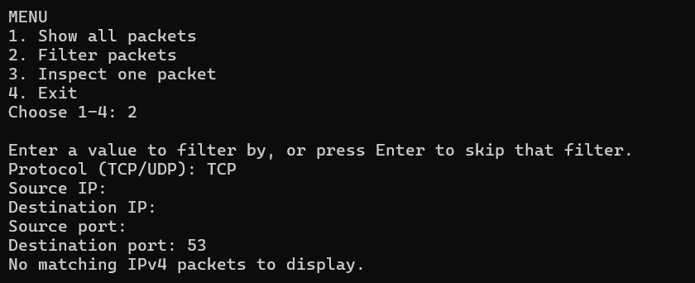
Result: No match, because the DNS traffic in this capture used UDP, not TCP.
(o) Testing the filter option with all fields left blank
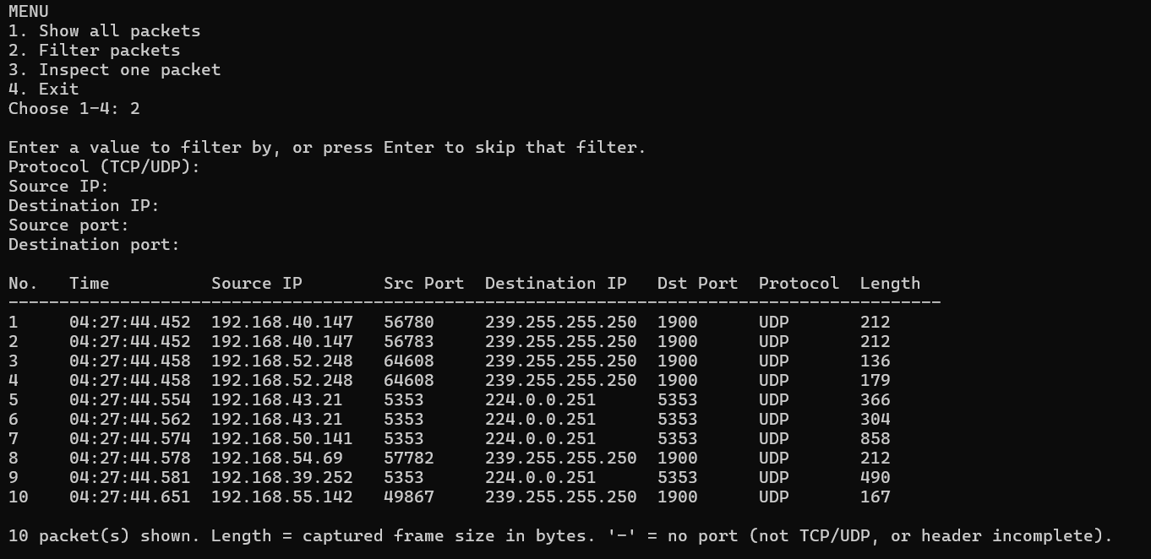
Result: With no filters, every captured packet was shown (10 packets in this capture).
(p) Testing invalid protocol input (ICMP)
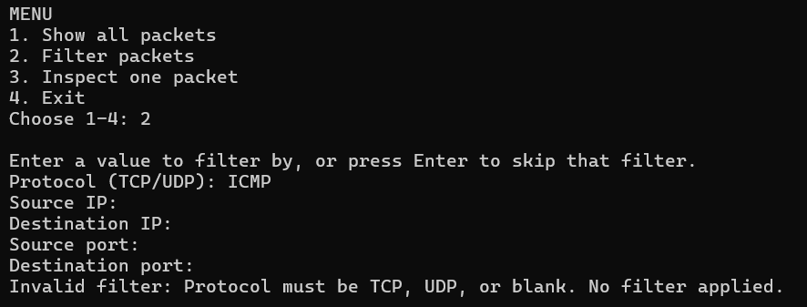
Result: Rejected, because protocol filtering supports only TCP and UDP, as the assignment specifies.
(q) Testing invalid source IP address
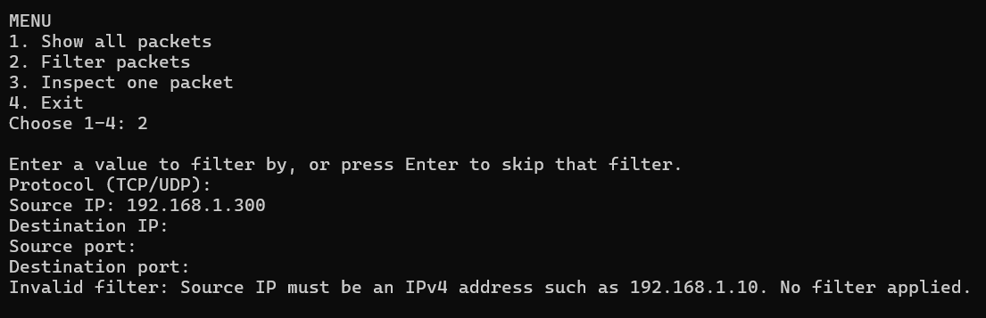
Result: Rejected, because 300 is not a valid octet (each part of an IPv4 address must be 0–255).
(r) Testing invalid destination IP address
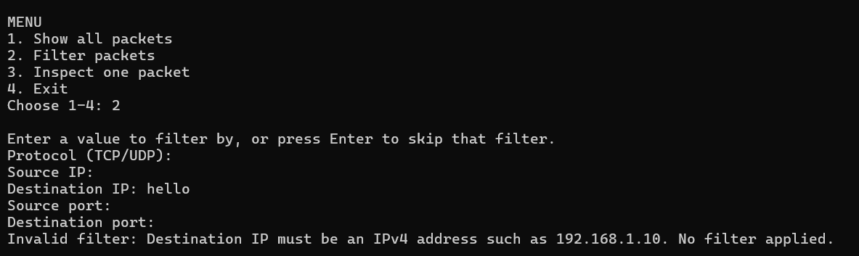
Result: Rejected as not an IPv4 address.

(s) Testing numeric input in the Source IP field
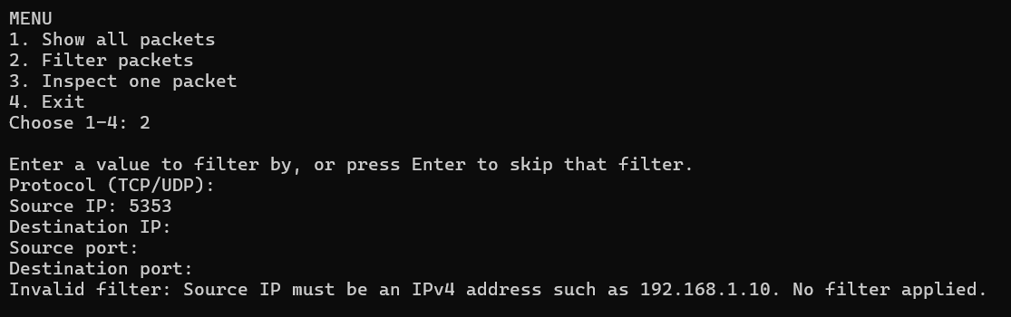
Result: Rejected; this catches the mistake of typing a port number into an IP field.
(t) Testing an invalid source port value
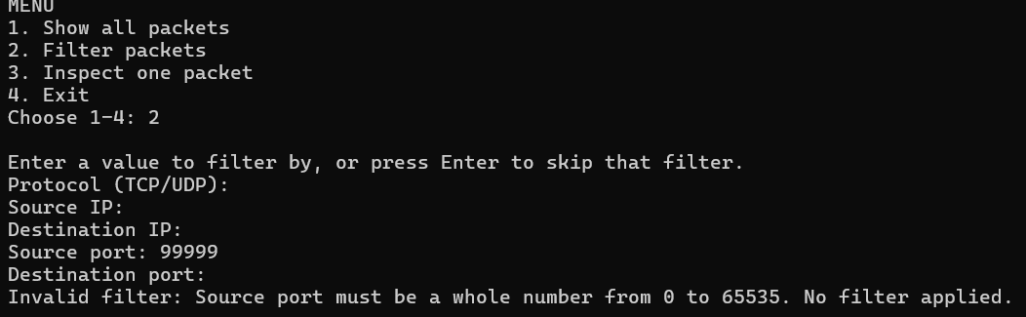
Result: Rejected, because ports are 16-bit numbers (0–65535).
(u) Testing a non-numeric destination port value
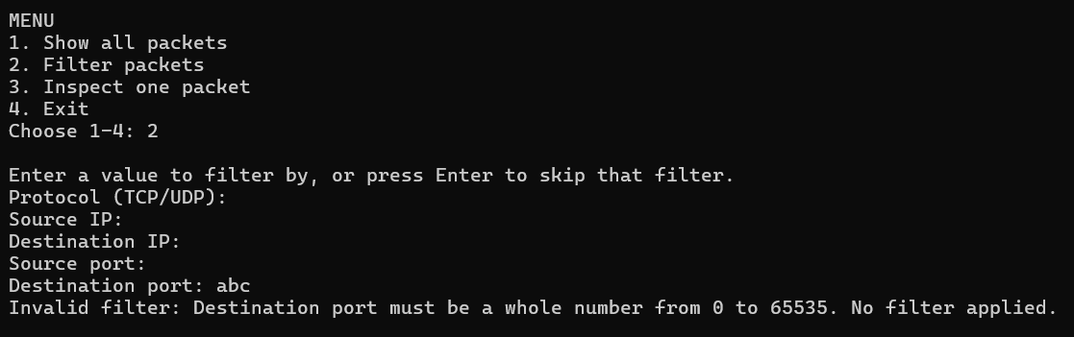
Result: Rejected as not a number.

(v) Testing a negative destination port value
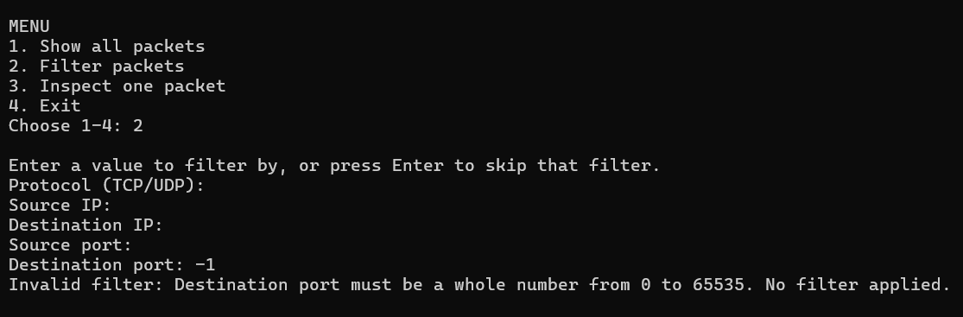
Result: Rejected as outside 0–65535.
6. Detailed Packet Inspection
- Inspecting an HTTP request packet
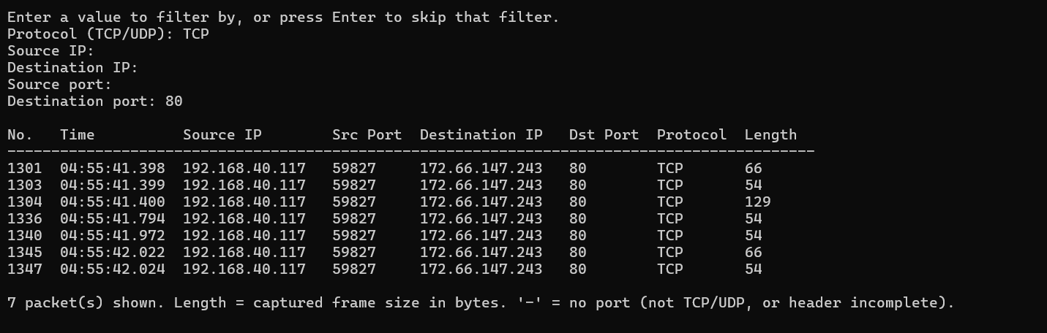
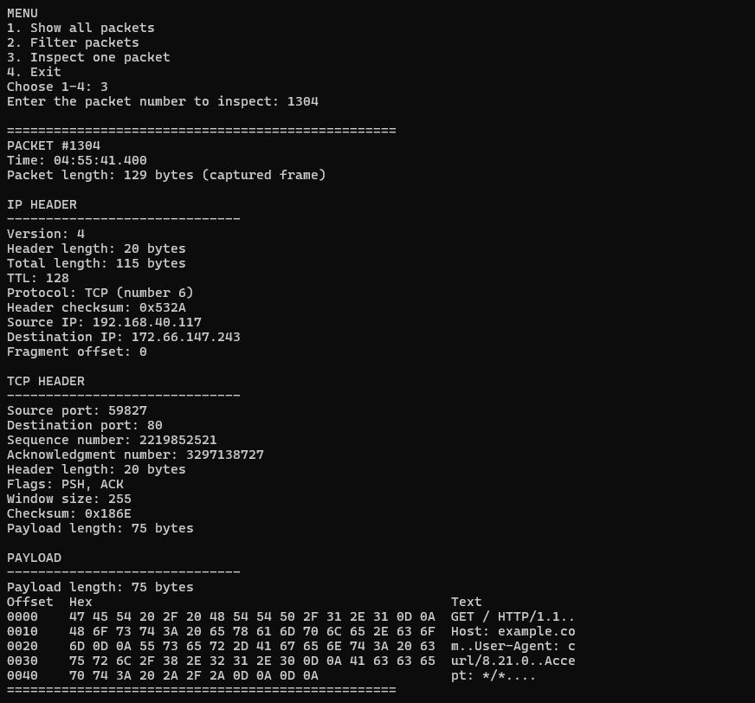
Result: This is the GET request sent by curl to example.com (packet 1304). The IP header shows version 4, a 20-byte header, total length 115 and protocol TCP (6). The TCP header shows destination port 80 and flags PSH, ACK. The payload text shows "GET / HTTP/1.1", "Host: example.com" and "User-Agent: curl/8.21.0". The lengths agree: 20 (IP header) + 20 (TCP header) + 75 (payload) = 115 (IP total length), and 14 (Ethernet header) + 115 = 129 (frame length).
- Inspecting an HTTP response packet
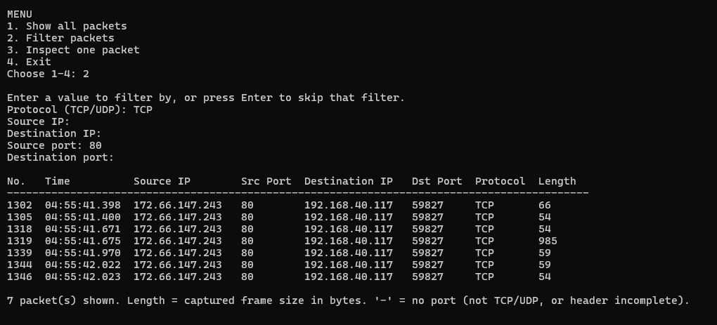
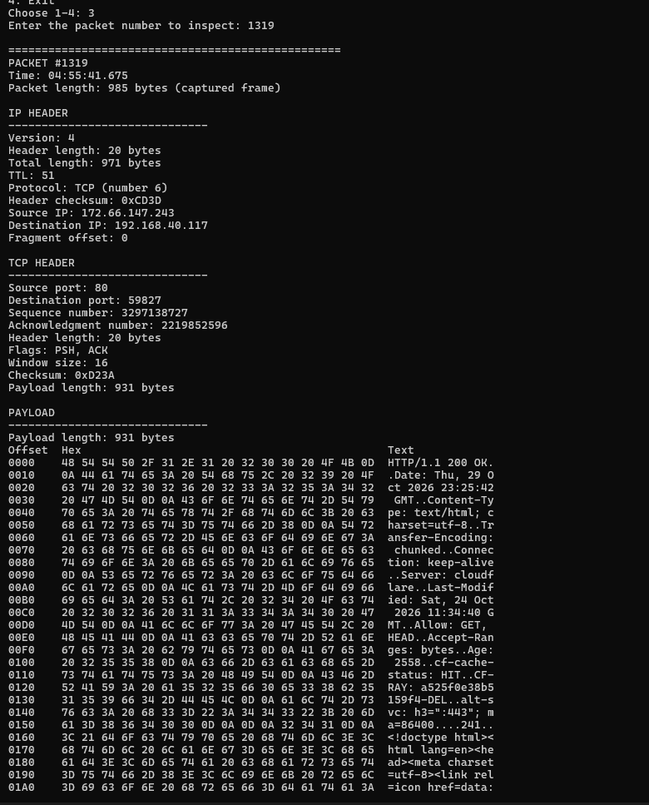
Result: The server's reply (packet 1319) comes from source port 80. The payload begins "HTTP/1.1 200 OK" followed by the response headers and HTML. The payload length is 971 − 20 − 20 = 931 bytes. Its acknowledgment number (2219852596) equals the request's sequence number (2219852521) plus the request's 75 payload bytes, which shows the server received the whole request.
(c) Inspecting a TCP SYN packet
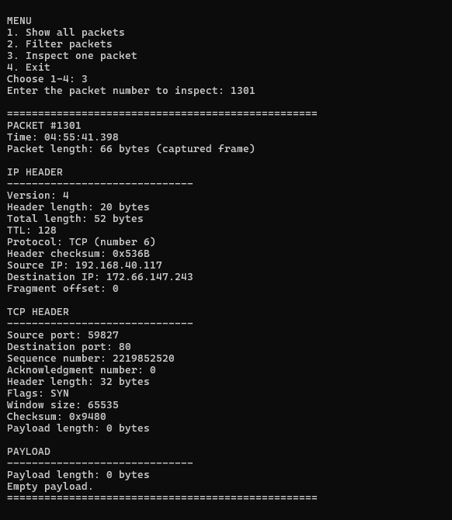
Result: The first packet of the connection (packet 1301) has only the SYN flag, an acknowledgment number of 0 and an empty payload ("Payload length: 0 bytes", "Empty payload."). The TCP header is 32 bytes rather than 20 because a SYN carries TCP options.

(d) Inspecting a TCP SYN-ACK packet
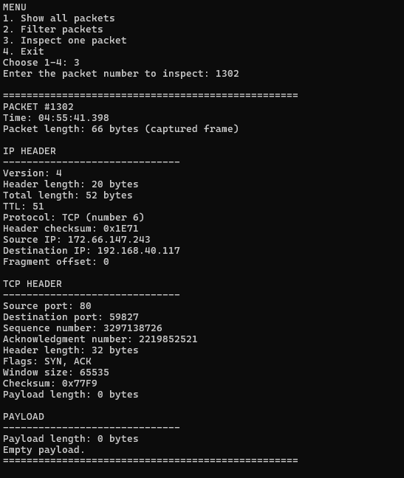
Result: The server answers with SYN, ACK (packet 1302). Its acknowledgment number (2219852521) is the SYN's sequence number (2219852520) + 1, as the TCP handshake requires.

(e) Inspecting a DNS query packet
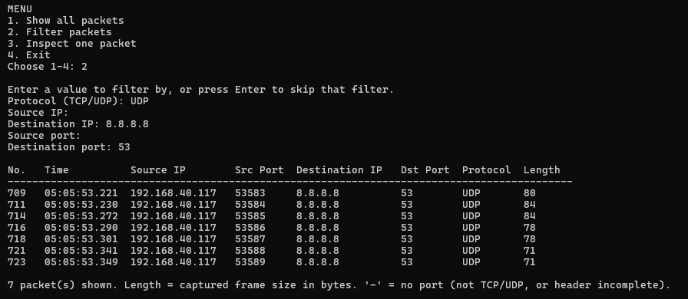
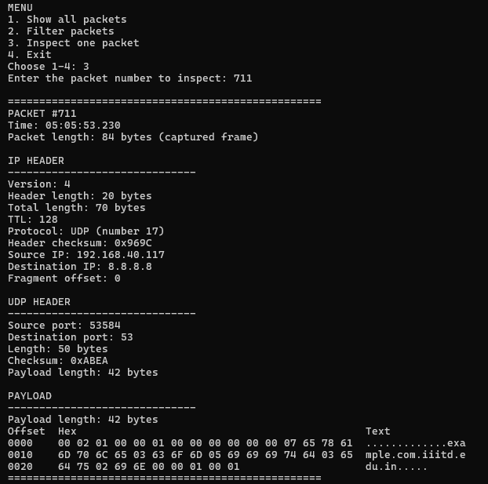
Result: A UDP packet to 8.8.8.8 port 53 (packet 711). UDP length 50 = 8 (header) + 42 (payload), and IP total length 70 = 20 + 50. In the payload, each part of the name is preceded by its length byte: 07 then "example", 03 then "com". The name appears as "example.com.iiitd.edu.in" because Windows adds its DNS search suffix (iiitd.edu.in) to some queries.

(f) Inspecting an HTTPS packet
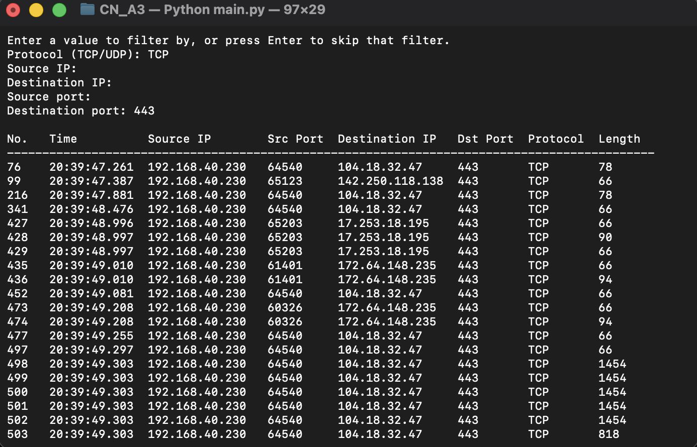
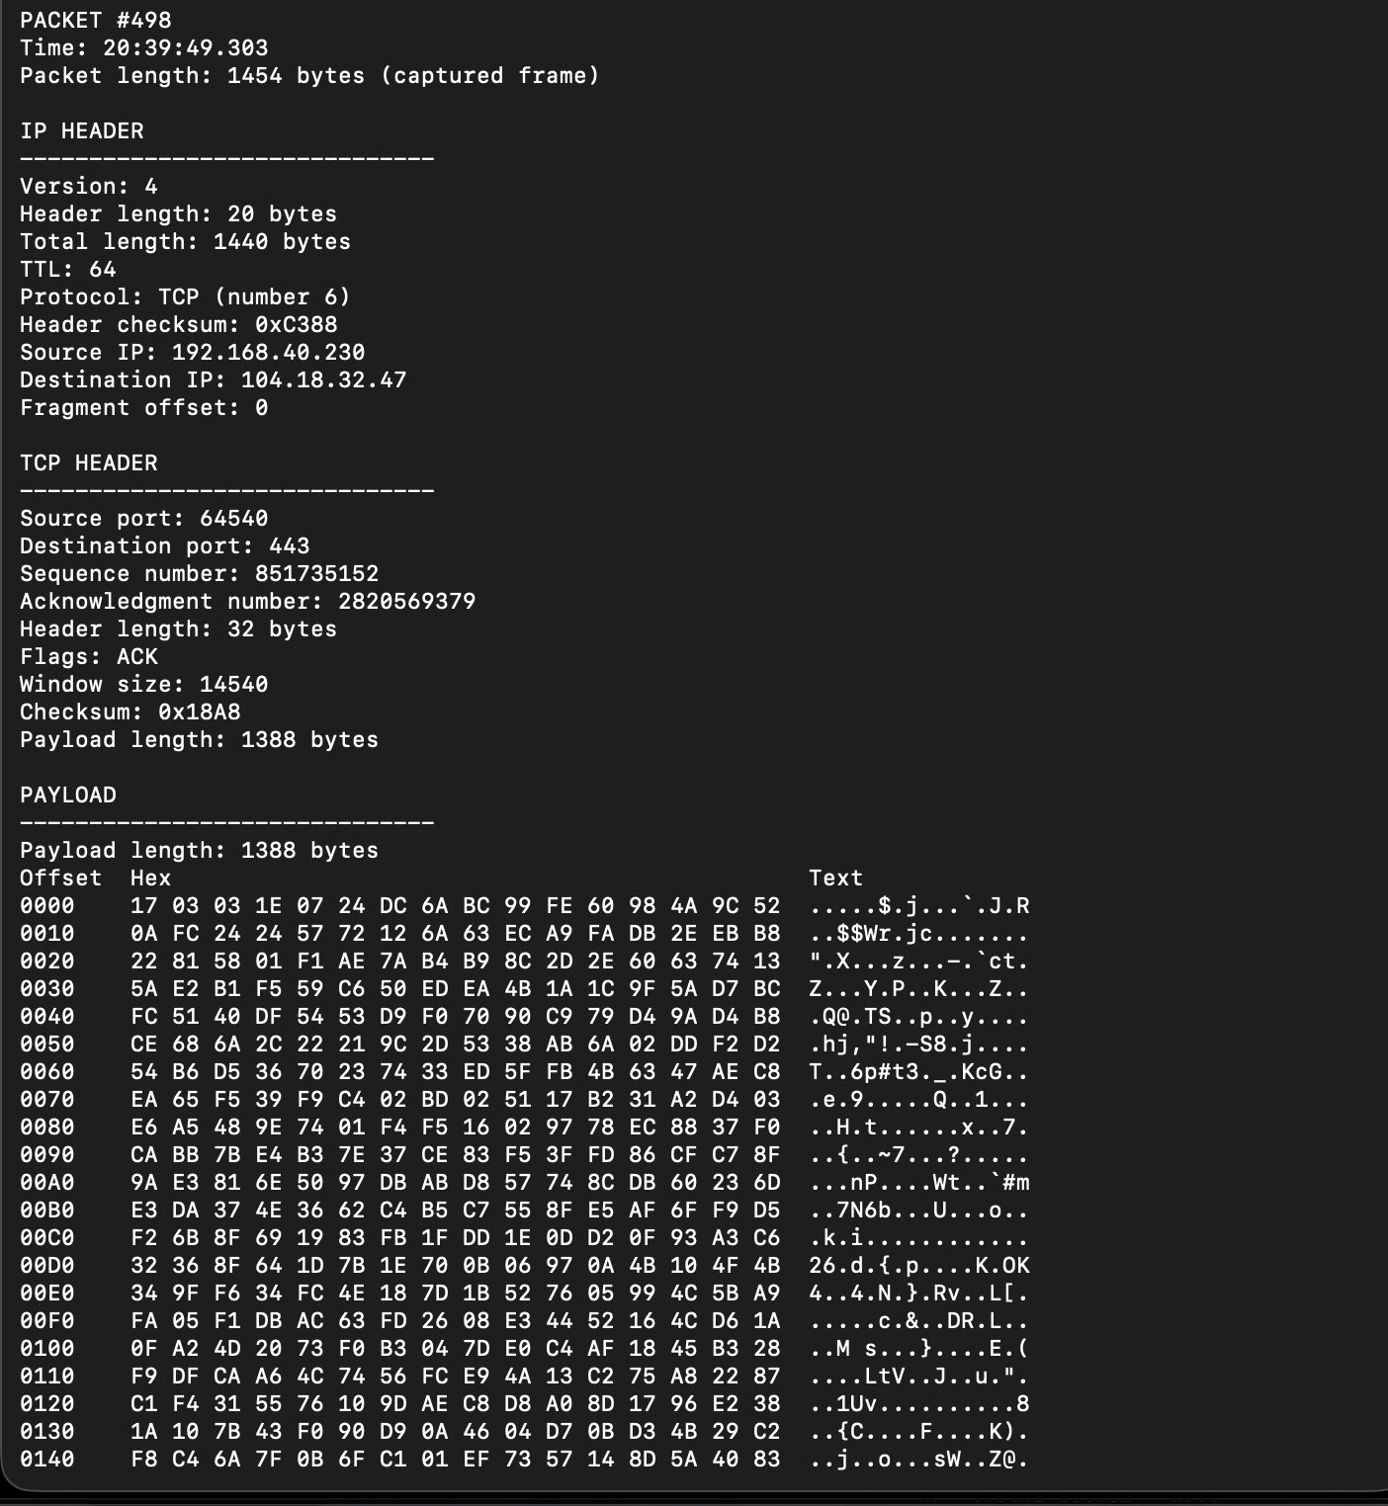
Result: Packet 498 is an HTTPS packet sent from the Mac to 104.18.32.47 on port 443. The lengths agree: 14 (Ethernet header) + 1440 (IP total length) = 1454 (frame), and 20 (IP header) + 32 (TCP header) + 1388 (payload) = 1440. All IP and TCP header fields are decoded as usual, but the payload looks random and the text column is mostly dots. This is expected: HTTPS payloads are encrypted with TLS. The payload begins with 17 03 03, which marks a TLS record carrying encrypted application data.
(g) Checking UDP port 443 using QUIC
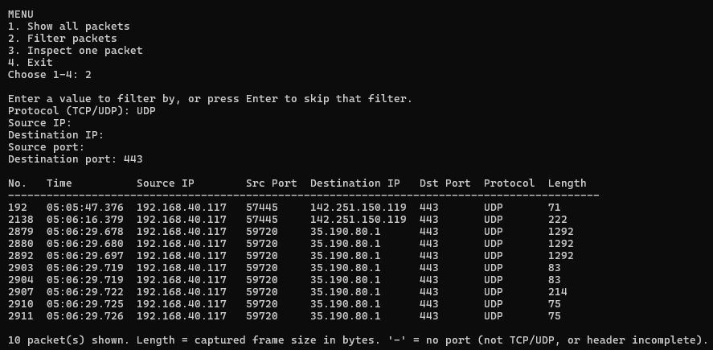
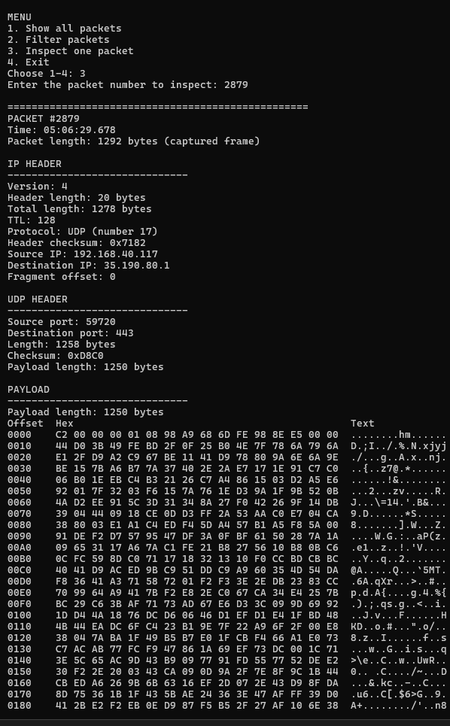
Result: A UDP packet to port 443 (packet 2879). UDP length 1258 = 8 + 1250 (payload), and IP total length 1278 = 20 + 1258. QUIC (used by HTTP/3) encrypts its data, so the payload is unreadable, as expected.
7. Menu Error Handling and Program Exit Tests
- Testing an invalid menu choice
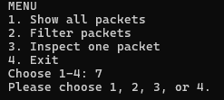
- Testing Blank Menu Input
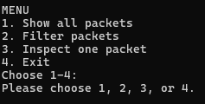
(c) Testing a Non-Numeric Packet Number
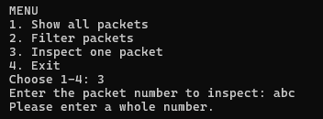
(d) Testing a Packet Number That Does Not Exist
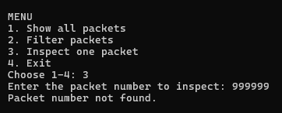
(e) Testing a Negative Packet Number
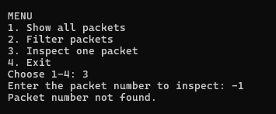
(f) Testing Program Exit
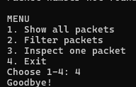
Result: Every invalid input produced a clear message and returned to the menu instead of crashing, and option 4 exited cleanly with "Goodbye!".
Challenges and fixes
- Incoming packets missing on Windows. During testing on Windows, the HTTP request appeared but the server's replies did not. Inspecting the raw bytes showed that incoming frames on that Wi-Fi network carried an 802.1Q VLAN tag (EtherType 0x8100), which the parser was skipping. The parser now skips the 4-byte tag and reads the real EtherType, so packets received by the host are decoded too.
- Windows interface names. On Windows, Scapy names interfaces like \Device\NPF_{GUID}, and the program defaulted to the macOS name en0. The program now lists interfaces by number with friendly names (such as "Wi-Fi") and picks the system's default interface.
- Unclear filter results. Previously, an invalid port or IP simply returned no packets, which looked like "no matches". Filter values are now validated and errors are reported.
- Unreadable payloads. Printing payload bytes directly could break the terminal output (for example with newline or escape characters). The payload is now shown as a hex dump with non-printable bytes displayed as ".".

Limitations
- Only Ethernet frames carrying IPv4 are decoded (with or without one VLAN tag). IPv6, double-tagged frames and later IP fragments are not fully decoded.
- Checksums are displayed but not verified.
- Protocol filtering supports TCP and UDP only, as the assignment specifies, and each IP or port filter matches one direction (source or destination).
- The Length column in the summary is the captured frame size (including the Ethernet header); the IP total length is shown in the detailed view.
- The payload text column shows ASCII only.
Privacy and authorization
All captures were made on our own computers, on a network we were authorized to use. Captured payloads can contain private information such as device names and local addresses, so no raw packet captures were committed to the repository.
Conclusion
We built a command-line packet analyzer that captures live traffic, decodes the IPv4, TCP and UDP headers directly from raw bytes, and lets the user filter packets and inspect each one in detail. All three offline test suites pass, and live tests on macOS and Windows confirmed every requirement of the assignment, including a full TCP handshake, a readable HTTP request and response, DNS queries over UDP, and encrypted HTTPS and QUIC traffic. Working at the byte level showed us how each header field maps to specific bytes and bits, and how real networks add details such as VLAN tags and TCP options that a parser has to handle.

AI Usage
The following prompts were used:
- Analyse my entire CN_A3 repository. Trace the execution of the program from startup to exit. Identify every module, function, algorithm, data structure and dependency. Explain how the modules interact and identify the actual implementation decisions made in the code. Do not modify anything yet.
- Trace and analyse the packet capture implementation in my source code. Identify how Scapy captures raw frames, how interfaces are discovered and selected, how capture duration and packet limits work, and how raw frames are passed to the parser. Document the actual implementation with relevant code references.
- Analyse my parser implementation line by line. Explain how Ethernet, VLAN, IPv4, TCP and UDP headers are decoded manually from raw bytes. Identify byte offsets, header lengths, bit operations, field extraction, payload boundaries and packet-length calculations. Explain the algorithms using actual code examples from my repository.
- Analyse filters.py and display.py in detail. Trace how protocol, source IP, destination IP, source port and destination port filters are validated and applied. Explain combined filtering, packet numbering, detailed packet inspection, hexadecimal dumps and ASCII payload rendering. Include the actual functions and algorithms used.
- Analyse all three offline test suites and the manual testing evidence in my report. Explain what each test verifies about the implementation. Document the debugging process and actual fixes, particularly VLAN-tagged frames, Windows interface discovery and invalid filter handling. Match the test results to the assignment checklist and screenshots. Do not invent results.

